Absolutely, Bashir! Here’s a clear, practical business plan and roadmap tailored for your new cloud engineering company—focused on deployment, configuration, resource optimization, and cost-saving consulting. This is written to help you go from idea → launch → growth, with structure you can immediately act on.

Business Plan: Cloud Engineering & Optimization Services Company
1. Executive Summary
Your company will provide end-to-end cloud engineering services, helping businesses deploy workloads, optimize infrastructure, reduce operational costs, and enhance cloud performance. You will target organizations using Azure, AWS, or GCP, especially SMEs that lack in-house cloud expertise.
Mission
To deliver reliable, secure, and cost-efficient cloud engineering solutions that empower companies to scale with confidence.
Vision
Become a preferred cloud engineering partner for businesses across India and globally by offering premium consulting and automation-driven optimization.

2. Services Portfolio
A. Cloud Deployment & Migration
- Architecture design and review
- Lift-and-shift migrations
- Greenfield deployments
- CI/CD pipeline setup
- Infrastructure-as-Code (IaC—Terraform, Bicep, CloudFormation)
B. Cloud Configuration & Management
- Identity and Access (IAM) setup
- Networking (VNet/VPC), load balancers, gateways
- Container orchestration (AKS/EKS/GKE)
- Database provisioning & tuning
C. Resource Optimization
- Rightsizing compute/storage
- Cleanup of idle or orphaned resources
- Auto-scaling configuration
- Performance tuning
- Architecture modernization
D. Cloud Cost-Saving Consulting
- Monthly cost audits
- Cost forecasting & reporting
- Reserved instance savings
- Storage lifecycle policies
- Optimization recommendations and implementation
E. Managed Cloud Support (Monthly Retainer)
- Monitoring, alerting, incident response
- Security & compliance checks
- Monthly performance/cost reports

3. Target Market
Primary:
- Small & Medium Enterprises (SMEs) shifting to cloud
- Mid-size companies with multi-cloud setups
- Startups needing quick and optimized deployments
Secondary:
- IT consulting firms needing cloud subcontractors
- SaaS product companies
- Global clients from Upwork, Fiverr, LinkedIn, Clutch

4. Pricing Strategy
One-time Projects
- ₹95,000–₹3,50,000 for deployments/migrations
- ₹50,000–₹1,50,000 for optimizations
- ₹20,000 for a one-time cost audit
Monthly Retainers
Plan | Price | Services
Basic | ₹25k–₹40k | Monitoring + admin tasks
Standard | ₹60k–₹1L | Optimization + support
Premium | ₹1.5L–₹3L | DevOps + SRE-level support
Hourly Consulting
₹2,000–₹5,000/hr depending on expertise

5. Customer Acquisition Strategy
A. Start with a strong online presence
- Website showcasing services, pricing, and case studies
- LinkedIn page + personal brand marketing
- Tech articles on “Cloud Cost Savings”, “Azure Optimization Tips”
B. Leverage your existing network
Your background in tele account management gives you a strong edge for B2B outreach.
C. Funnel strategy
- Cold outreach via LinkedIn
- Cloud audit offered free or discounted as a lead magnet
- Convert to optimization or monthly retainer
D. Marketplaces
- Upwork (cloud engineering + optimization niche)
- Clutch & GoodFirms listings
- Partner with MSPs who need project-based cloud help

6. Operations Plan
Phase 1 — Solo/Small Team
- You act as the primary cloud engineer + consultant
- Hire 1 contractor for DevOps tasks (CI/CD pipelines, IaC)
- Outsource website + branding initially
Phase 2 — Build Team
- Cloud Engineer (1)
- DevOps Engineer (1)
- Customer Success/Support (1)
- Sales & Partnerships (You continue leading)
Phase 3 — Standardize
- SOPs for deployments
- Reusable Terraform modules
- Cloud audit templates
- Proprietary cost optimization framework
- Build a dashboard showing customer cost savings (value booster)

7. Financial Analysis (Year 1 Projection)
Revenue Targets
- 3 projects per quarter (avg ₹1.5L each) = ₹18L
- 4 clients on monthly retainers (avg ₹70k) = ₹33.6L
Total Revenue Year 1: ≈ ₹50–55 Lakhs
Expenses
- Salaries → ₹15–20L
- Tools/Software → ₹2L
- Marketing → ₹1.5L
- Website/Branding → ₹50k
Expected Profit Year 1: ₹20–25 Lakhs

8. Legal & Compliance
- Register as Private Limited or LLP
- GST registration
- NDA + MSA templates
- Azure/AWS/GCP partner program registrations
- Create service contracts with scope & SLAs

9. Brand Positioning
Suggested Company Names (if needed):
- CloudOptiTech
- SkyOps Consulting
- CloudSage Engineering
- OptiScale Labs
- CloudCraft Solutions
Tagline Ideas:
- “Optimize. Deploy. Save.”
- “Smarter Cloud. Lower Costs.”
- “Engineering your Cloud Advantage.”

10. 12-Month Roadmap
Q1: Foundation
- Finalize services, pricing, legal structure
- Build website + LinkedIn presence
- Create reusable templates (IaC modules, audit checklist)
- Start outreach and acquire first 2 clients
Q2: Scale Delivery
- Execute deployments + optimization projects
- Build case studies
- Launch cloud cost-audit service
- Secure 2–3 retainer clients
Q3: Build Brand
- Publish 10 blogs
- Start YouTube tutorials (optional)
- Attend cloud conferences (virtual/in-person)
- Hire part-time DevOps engineer
Q4: Expand
- Launch automation tools (scripts, modules)
- Scale retainers to 5–6 clients
- Register for partnerships (AWS/APN, Azure MSP etc.)
- Build SaaS-like features (e.g., cost monitoring dashboards)
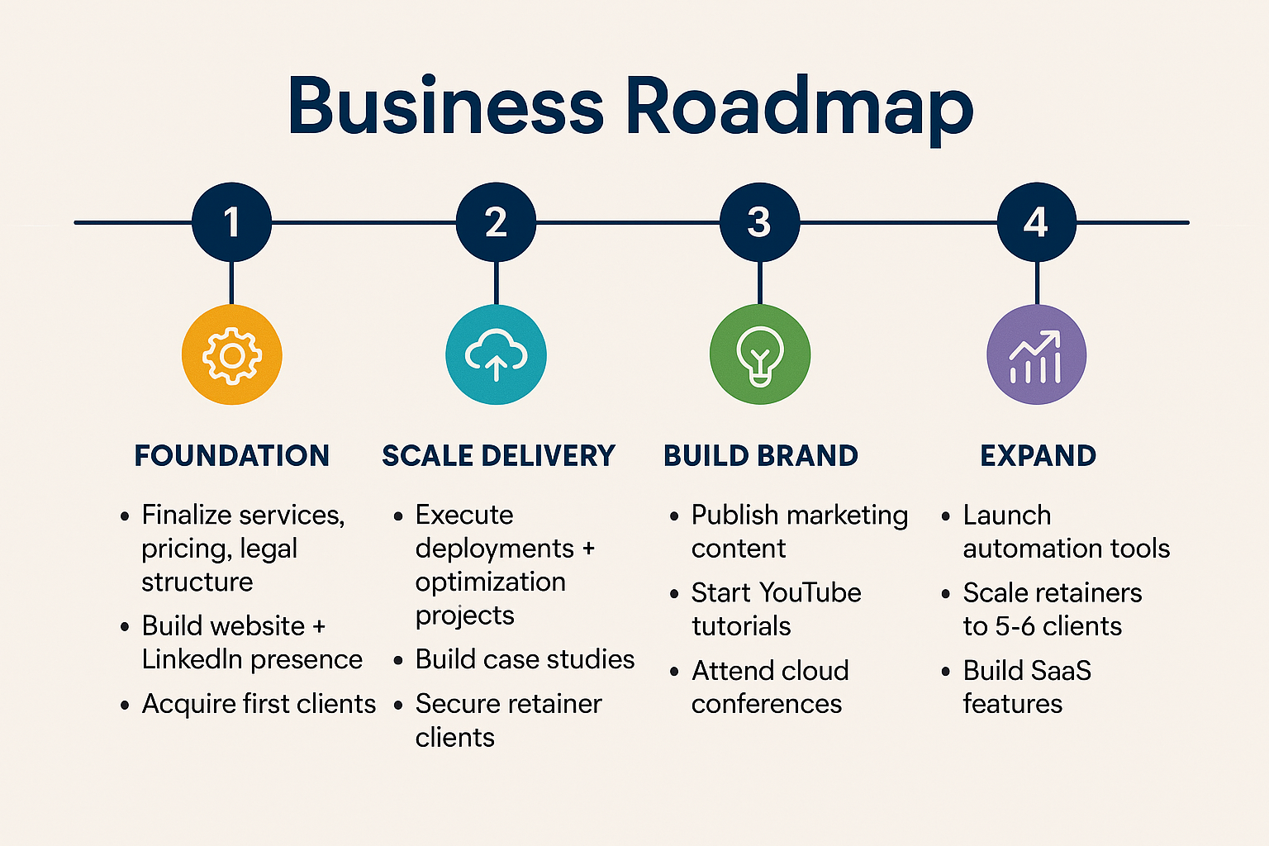

Would you like me to also create:
✔ A pitch deck (PowerPoint)
✔ A 1-page investor summary
✔ Company name + logo ideas
✔ Your first website homepage content
✔ A full business roadmap in timeline/graphic format
Just tell me what you want next—I’ll create it!

